TU KY TOWN PRIMARY SCHOOL  Full name: .................................................  Class: 3…… |  |  |  |  |  | THE FIRST TERM TEST  SCHOOL YEAR 2022-2023  SUBJECT: ENGLISH- GRADE 3  TIME: 40 minutes
 | Marks | Listening | Speaking | Reading and writing |  |  | Comments
- LISTENING (4 marks)
Question 1. Listen and tick or cross (1 mark)
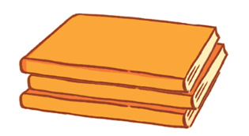 |  | 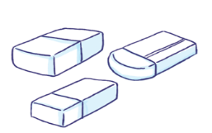 | 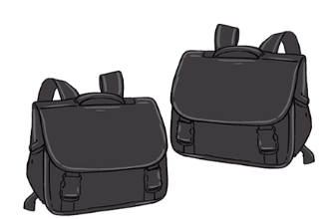
Question 2. Listen and circle (1 mark )
1.A. I have a book.
B.Does she have an eraser?
2. A. I’m Mary.
B. My name’s Nam.
3. A. Let’s go to the playground.
B.Is your classroom big?
4.A.Speak English, please.
B. May I stand up?
Question 3. Listen and complete( 1mark )
Do you have a ………………………? Yes, I do.
- What colour is it? It’s……………………..
- What’s this? It’s a …………
- I like ………………………..
Question 4. Listen and tick in the box( 1 mark )
1 | A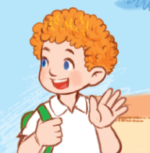 | B 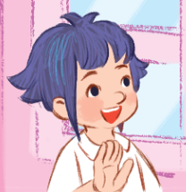 | C 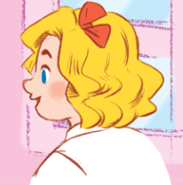
2 | 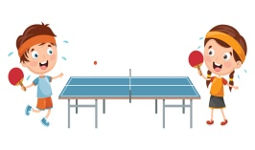  A | B 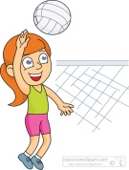 | C 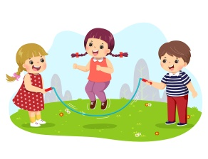
3 | 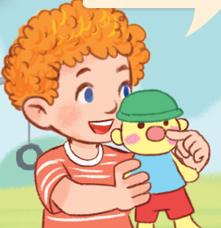  A | 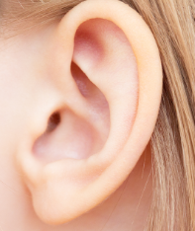  B | 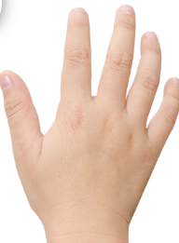  C
4 | A | B | C

B. READING AND WRITING (4marks)
Question 5. Look at the pictures and match the sentences:( 1 mark )
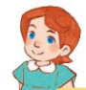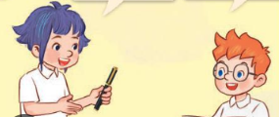
1 2 3 4
D.I have a pen.
A.Is that Lucy? Yes, it is.

C.What’s this? It’s a nose.
B.Is that the classroom? No, it isn’t. It’s the library.

Question 6. Read and tick( 1 mark ) :
- Do you have an eraser? Yes, I do.
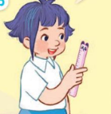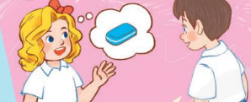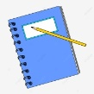
- b. c.

- A: What’s your hobby?
B: It’s singing.
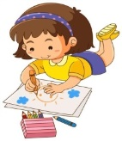
- b. c.

- Close your book, please.
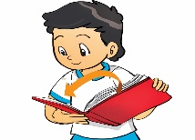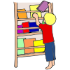
- b. c.

- It’s an eye.
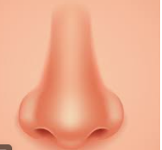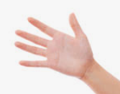
- b. c.

Question 7. Reorder the words to make correct sentences: (1 mark )

- cooking. /like /I
=>………………………………………………………………….
2. Is /that /gym? / the
=> …………………………………………………………
3. nine /years/ I /old. /am
=>………………………………………………………………
4. colour /What /notebooks? /are /the
=>……………………………………………………

Question 8. Look and write ( 1 Mark )
_ _ _ _ _ _ _ | 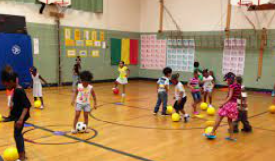  _ _ _ | _ _ _ _ | _ _ _ _

C. SPEAKING. ( 2 Marks )
- Look, point and say.
- Listen and answer the questions .
- Let's talk

KEY : BÀI KIỂM TRA HỌC KÌ 1 LỚP 3 GLOBAL
I. LISTENING
Question 1. Listen and tick or cross
Key: 1 2A 3x 4
Question 2. Listen and write True or False ( T) (F)
Key: 1.B 2.A 3.B 4.A
Question 3. Listen and complete.
1.C 2.A 3.A 4.C
Question 4
1.pencil case 2.blue 3.hand 4.cooking
II. READING AND WRITING
Question 5
1.b 2.b 3.b 4.c
Question6 :
1.C 2.A 3.B 4.D
Question 7: Reorder the words.
- I like cooking.
- Is that the gym ?
- I am night years old.
- What colour are the notebooks ?

Question 8:
- Singing 2.Gym 3.Swim 4.Hand

- LISTENING:

Question 1: Listen and tick or cross:

1 These are my books
2 Is this your book? Yes, it is
3 What color are your erasers? They are red.
4 they are my school bag. They are black.

Question 2: Listen and circle:

1 Does she have an eraser?
2 I’m Mary.
3 Is your classroom big?
4 Speak English, please.

Question 3: Listen and tick in the box:

1 hello what’s your name? My name is Mary.
2 What do you do at break time? I play table tennis
3What’s this? It’s a nose
4 Is this a book? Yes, it is.
Question 4: Listen and complete:
1.Do you have a pencil case? Yes, I do.
2 .What color is it? It’s blue
3.What’s this? It’s a hand.
4. I like cooking.

